**APPLICATION South Shore Soup**

Name:

Address:

PH: Email:

Project Name:

Project Summary:

Tell us specifically how you will use SOUP grant funding **\* Ex. What are costs that you will defray? What items do you intend to buy? Will you put money towards permits?**

How will this project impact the community of Cudahy, St. Francis or South Milwaukee **Ex. What problem will it solve? What benefit does it offer? What will it improve?**

What is project timeline? **Ex: when would you start your project? How long will it take? What barriers do you foresee? Will your project be completed by spring 2020 for discussion at the next Soup?**

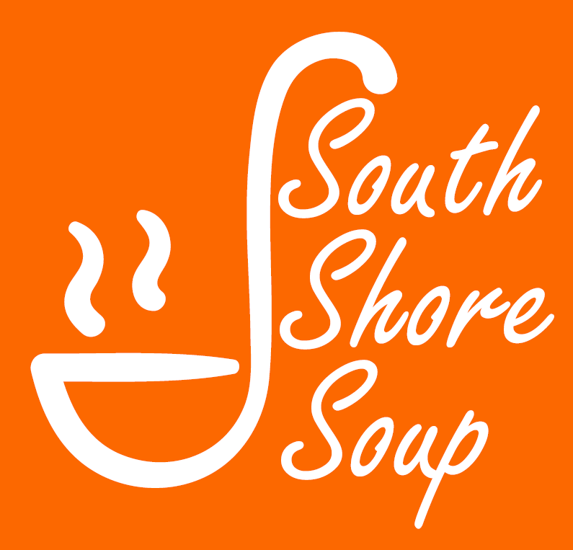Fund your community project with support from your neighbors – anything from filling a pothole, to funding a class field trip, to starting a new business. Attendees pay $10 for soup, salad & dessert and vote on which project they think benefits the community the most. The winner goes home with all of the money raised at the door to carry out their project. At the dinner, residents and supporters connect, share ideas, and community resources. The whole project is sponsored by various businesses who donate the soups, salad, and desserts, and the South Shore Chamber of Commerce who handles guest registration and issuing the final check to the award recipient.

Email the South Shore Chamber at infossccwi@gmail.com with the answers to the questions on our application. (use an extra page if needed)

* The idea must be for Cudahy, St. Francis, or South Milwaukee.
* Your proposal can be about anything and doesn’t need to be a novel, short quick and to the point works.
* You do not have to be a resident to submit an idea, and age is just a number so please don’t limit yourself or a child! We want to hear from all.
* If your idea doesn’t get selected for this SOUP, then SUBMIT AGAIN! Only 3 submissions are chosen to share at the SOUP, but don't be discouraged! Check back for information on the next SOUP event in April & October 2020. You can submit for another Soup.
* Submission deadline: Feb. 7, 2020 – Winners notified February 10, 2020  
  Date of Soup: Sunday, Feb. 16, 2020Event location: Cudahy United Methodist Church, 5865 S. Lake Drive, Cudahy WI   
  Event time: 4PM-7PM (*4:30pm Soup Dinner, 5:30pm Presentations, 6p.m. Dessert)*
* Do you have questions about submitting? Call CoryAnn, South Shore Soup Coordinator at 414-255-8555.

*Email this application to the South Shore Chamber of Commerce  
email: infossccwi@gmail.com*